[Name:](https://www.techinasia.com/category/startups) **[Novelsys](https://www.techinasia.com/category/startups)**

[Created On:](https://www.techinasia.com/category/startups) **[31-Jan-22 12:01:23 AM](https://www.techinasia.com/category/startups)**

[Created By:](https://www.techinasia.com/category/startups) **[HEIDER](https://www.techinasia.com/category/startups)**

[Modified On:](https://www.techinasia.com/category/startups) **[25-Feb-22 7:17:55 AM](https://www.techinasia.com/category/startups)**

[Modified By:](https://www.techinasia.com/category/startups) **[HEIDER](https://www.techinasia.com/category/startups)**

[Size:](https://www.techinasia.com/category/startups) **[534 KB](https://www.techinasia.com/category/startups)**

**[¶1:](https://www.techinasia.com/category/startups)** [About Novelsys](https://www.techinasia.com/category/startups)

**[¶2:](https://www.techinasia.com/category/startups)** [Reinventing the Mobile Charging Experience.](https://www.techinasia.com/category/startups)

[¶3: Singapore, Central Region, Singapore](https://www.techinasia.com/category/startups)

[¶4: 1-10](https://www.techinasia.com/category/startups)

[¶5: Private](https://www.techinasia.com/category/startups)

[¶6: www.novelsys.co/](https://www.techinasia.com/category/startups)

[¶7: 701,218](https://www.techinasia.com/category/startups)

¶8:

**[¶9: Details](https://www.techinasia.com/category/startups)**

[¶10: Industries Consumer Electronics Electronics iOS](https://www.techinasia.com/category/startups)

[¶11: Headquarters Regions Asia-Pacific (APAC), Association of Southeast Asian Nations (ASEAN), Southeast Asia](https://www.techinasia.com/category/startups)

[¶12: Founded Date 2014  
¶13: Founders Delane Foo, Kenneth Lou, Mark Keong  
¶14: Operating Status Active  
¶15: Company Type : Startup](https://www.techinasia.com/category/startups)

[¶16: STARTUPS](https://www.techinasia.com/category/startups)

¶17:  Terence Lee · 15 Jan 2015 · 7 min read

# **¶18:** This 22-year-old hustler wants to build Asia’s 1st wireless charging network

¶19: 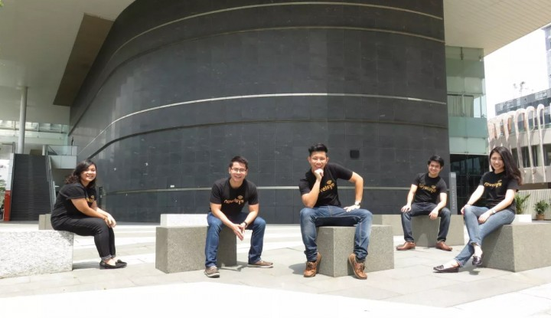

¶20: Novelsys founder Kenneth Lou (center) with the team.

¶21: 22-year-old startup founders are not supposed to be this polished, this well-networked, or this prepared. After all, older entrepreneurs are [more likely to succeed](http://www.forbes.com/sites/krisztinaholly/2014/01/15/why-great-entrepreneurs-are-older-than-you-think/) than fresh-faced college kids because of their abundant professional experience.

¶22: But Kenneth Lou, the founder of Novelsys, a Singapore-based startup with the stated mission of “powering the world”, thinks he’ll be the exception.

¶23: “I have slide decks for everything,” Lou says as he pitches his company’s plans. He fishes out a deck with his thoughts on student entrepreneurship – he’s doing a gap year at the National University of Singapore. He then opens another one on the founding team’s journey.

¶24: He’ll need all the gumption he can muster. Novelsys’ plan would challenge even seasoned entrepreneurs. Today, the company launched a [Kickstarter crowdfunding campaign](http://kickstarter.novelsys.co/) for Ampere, a wireless charging sleeve for mobile devices based on the Qi standard, an inductive electrical power transfer system created by the Wireless Power Consortium.

¶25: AD. Remove this ad space by [subscribing](https://www.techinasia.com/subscription?ref=banner-ad-top).

¶26: It’s supposed to be more user-friendly than existing power banks by removing the need for wires. It’s smarter too, with a companion app that lets users preset the points where the phone would start or stop charging.

¶27: The Ampere is also not phone-specific, making it more flexible than [charging cases like the Mophie](http://www.macworld.com/article/2045268/review-best-battery-cases-for-the-iphone-5.html). Slot a Qi-enabled phone into the sleeve and the battery will start filling up. For devices like the iPhone, the Ampere ships with a casing and a removable receiver patch.

¶28: 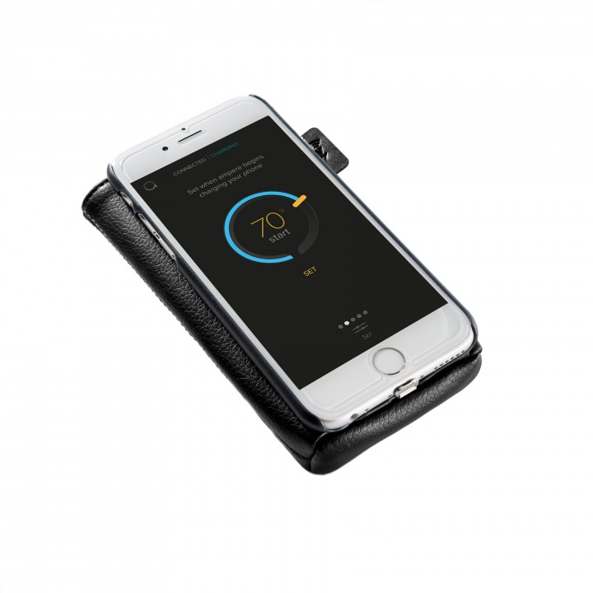

¶29: With a battery capacity of 2,700 mAh and a retail price of US$99, the patent-pending Ampere seems costly compared to battery packs from Xiaomi and others. These cost five times less but have four times the capacity. But Lou hopes he can bring the cost down in subsequent production runs.

¶30: Assuming he gets that far. Fellow Singapore startup Pirate3D [learned the hard way](https://www.techinasia.com/refunds-pirate3d-backers-mistakenly-delayed-years-sparking-complaints/) that crowdfunding campaigns are fraught with landmines once the euphoria of achievement dies down.

¶31: Dealing with hardware in addition to software means an extra ball to juggle. Manufacturing defects cause startups to miss the promised delivery date. As a result, disgruntled customers might demand a refund, and that puts a strain on cashflow. That’s a lot of trouble for a device that seemingly offers only incremental improvements over existing products.

¶32: AD. Remove this ad space by [subscribing](https://www.techinasia.com/subscription?ref=banner-ad-top). [Support independent journalism.](https://www.techinasia.com/subscription?ref=banner-ad-bottom)

¶33: While Novelsys is currently selling Ampere at a loss of a few dollars a unit, he says that shifting the devices at a much higher volume would make up for it. “The campaign for us is one big expensive marketing shebang,” he says. Retail distribution is key too, but that comes in later.

¶34: 

### ¶35: Phase two

¶36: Despite the company’s devotion to launching Ampere now, it’s just a piece of the Novelsys jigsaw. Lou has a second product waiting in the wings – and it’s not so much a hardware device than a vast charging network powered by Novelsys tech.

¶37: Appropriately called Juice, the network will consist of wireless charging stations to be placed throughout a city, particularly in cafes and restaurants. Visitors use it for free by registering their details on an app. Cafe owners pay a subscription fee. No rewiring would be necessary as charging pads will be powered by rechargable batteries.

¶38: In return, business owners push targeted advertising and increase per-visitor spend by offering promotions in exchange for more charging time. While the idea is new in Asia, it has a precedent – Starbucks and Duracell Powermat struck a deal in 2014 to install charging mats [in 200 Starbucks stores](http://www.digitaltrends.com/mobile/starbucks-pma-wireless-charging-launched/) in San Francisco. The coffee chain could bring the concept to Asia soon.

¶39: “Both Ampere and Juice create a charging ecosystem. We want you to be forever plugged in, in such a way that you’re pretty much charging everywhere – no need to worry.”

¶40: AD. Remove this ad space by [subscribing](https://www.techinasia.com/subscription?ref=banner-ad-top). [Support independent journalism.](https://www.techinasia.com/subscription?ref=banner-ad-bottom)

¶41: For Juice to stay viable, Lou must move fast and seize the Asian market. He hopes to roll out the technology in Singapore by June 2015 and expand nationwide by the end of the year on the backs of large F&B chains like Coffee Bean, Starbucks, or McDonald’s. He targets a regional expansion by mid-2016, which would make Novelsys an attractive acquisition for the likes of Powermat.

¶42: It’s evident that Lou has done this pitch dozens of times, and he comes across as confident without sounding rehearsed. He talks about Singapore’s goal of becoming a [smart nation](http://www.ida.gov.sg/blog/insg/tag/smart-nation/), and how it need three key resources to achieve it. The first is data. The second is power – whereby a city reaches a point where inhabitants don’t need to constantly think about where to recharge their devices.

¶43: “The third is coffee,” he says, pausing for effect. “When we pitch to Starbucks and Coffee Bean, that’s how we sell it.”

¶44: Yet a startup’s trajectory rarely follows the neat path set out on a slide deck, especially when wireless charging hasn’t settled on a standard. Powermat favors the Power Matters Alliance system while the Ampere is based on Qi. The situation echoes the War of Currents in the late 1880s when the alternating current (AC) standard won against the direct current (DC) proponents.

¶45: The dust hasn’t settled on the wireless standards fight. In the larger scheme of things, plenty of competing innovations are duking it out to be the future of battery tech, from graphene to [electronic skin](https://www.techinasia.com/singapore-inventor-solve-tech-health-problems-electronic-skin/) to [long-distance energy transfer](http://www.techradar.com/news/world-of-tech/wireless-power-could-cota-make-it-long-distance-and-mainstream--1197833).

¶46: Any of these technologies could render Novelsys a has-been, but Lou seems unfazed. “We don’t see ourselves as a specific technology group, we’re an infrastructure provider.” He namedrops Greg Mittman, vice-president at MyRepublic, as a mentor. The company is tackling Asia’s telco industry head on by [using cloud computing to reduce costs](https://www.youtube.com/watch?v=DvqaQQLDaUE).

### ¶47: Phase zero

¶48: 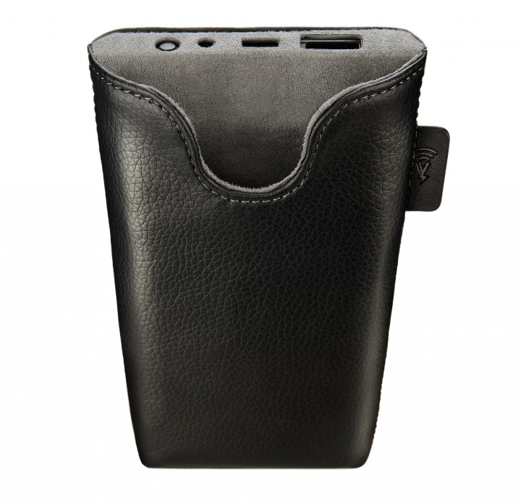

¶49: Lou makes it clear that he has done his homework before embarking on the crowdfunding campaign. He shows me a bill of materials which breaks down the cost of manufacturing each unit and how much he expects to make – or lose – with each unit sold.

¶50: He consulted with many Singapore hardware startups to get to this point. Lou says he’s in “close talks” with gaming device maker [Razer](https://www.techinasia.com/tag/razer) and wireless speakers company X-mini to get manufacturing advice and link-ups with contract manufacturers and distribution channels.

¶51: Lou also sought guidance from Singapore startups smart sex vibrator startup [Vibease](https://www.techinasia.com/tag/vibease) and Pirate3D. These conversations convinced him to assemble his first batch of Amperes in Singapore and avoid Shenzhen – China’s manufacturing hub.

¶52: He anticipates making up to 4,000 units in Singapore. If demand exceeds that, the manufacturer has another line in Batam – an Indonesian island near Singapore – ready to pick up the slack. Lou heard about many horror stories from Shenzhen, such as how parts were swapped out at the production line, and how designs were copied and counterfeits sold.

¶53: With the small initial batch, there’s no need to enter China yet since Novelsys would have an easier time inspecting the production lines, do quality control, and communicate with manufacturers if it assembles locally. Shenzhen makes sense only with volumes above 10,000.

¶54: Lou has taken a break from studies to work on Novelsys full-time. With him is a team of eight who’ve raised S$80,000 (US$60,000) from competitions and [iJam](https://www.techinasia.com/az-singapore-startup-grants-schemes/), a Singapore startup grant. The iJam accelerator they’re working with is [Focustech Ventures](http://www.focustechventures.com/).

¶55: Lou has an entrepreneurial streak. He once started a daily deals aggregation app while serving national service but his partner pulled out. His second venture was a company which organized events that would pay people to download and try apps. That failed as well after his co-founder “screwed him over.”

¶56: The National University of Singapore (NUS) Kent Ridge scholar started over in an unorthodox manner. He put up posters all over campus calling for co-founders for his venture with the title: “you are next Elon Musk.” No one responded. He then blasted out an email to NUS’s electrical engineering faculty. That’s how he met his co-founder Mark Keong, the startup’s engineering brain.

¶57: 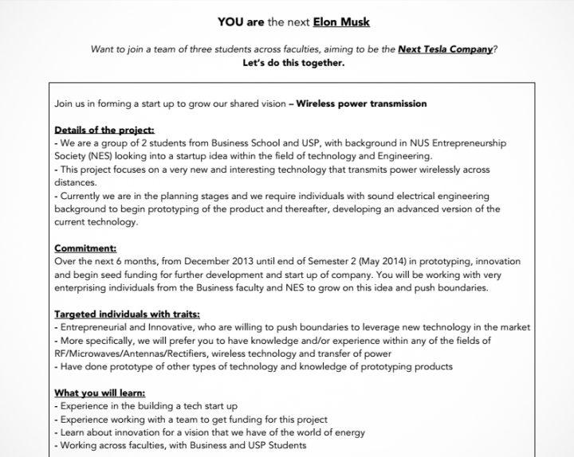

¶58: His pitch.

¶59: Keong then reached out to Delane Foo, an industrial designer he met in the Singapore Studies class. The trio went on a series of startup competitions, winning thousands of dollars. But startups aren’t meant to live on business plans alone.

¶60: Lou got his wake-up call when his mentor said: “Do you want to win a lot of business plan competitions, or do you want to start a scalable startup?” He got his iJam grant after that, and is now raising a S$110,000 (US$82,000) round with angel investors. He is targeting a S$600,000 (US$450,000) research grant from SPRING TECS, and foresees raising a US$4.5 million series A round two years down the road to roll out Juice in the region.

¶61: It’s a lot to learn for a kid, but Lou isn’t an ordinary one. He’s just one of the three fellows selected for the [Philip Yeo Initiative](http://www.overseas.nus.edu.sg/programmes-blog/21-applications/awards-scholarships/the-philip-yeo-initiative), an eponymous program named after one of Singapore’s most prominent civil servants. The initiative gives Lou access to Yeo and his network. This is crucial if you want to do something ambitious in a country where the government looms large in the economy. He’ll need all the help he can find.

¶62: “I’m only 22, and I always encourage youth entrepreneurship. We have no car loan, we have no children, we have no marriage loan to pay. We don’t have family and housing loans,” says Lou.

¶63: “We’re putting on hold our studies, but I always believe that the network that we get, the people we meet, are always more valuable than a degree.”

¶64: *Check out [Ampere’s Kickstarter page](http://kickstarter.novelsys.co/)*